1. What are the 4 stressors in social media according Parnell? Do you think they affect you as a user? How?

1)Highlight Reel, 2) Social Currency, 3) FOMO (Fear of Missing Out), 4) Online Harassment
Yes, they do. Specifically, for social currency, I used to have the period I worried about the number of likes and could not sleep.
2. Do you consider yourself addicted to social media? What do you usually do to keep yourself mentally well when using social media?

Yes, I am addicted to social media.
For keeping myself mentally, I set a timer for each social media and manage my time for using studies like English and IT.
3. How can brands contribute to a better social media environment in our society? Find an example to illustrate your argument.
Brands can contribute to a better social media environment in our society by raising awareness against slander and other forms of defamation.
Brands may be able to stop the slander of perpetrators who likes the brand through awareness-raising.


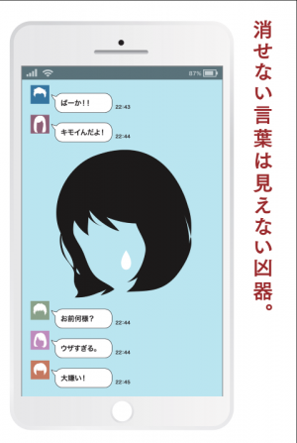
Unerasable words are invisible weapons

